Comparative Study for Isolation and Clean-up Procedure by
1

2
3
4
5
6
7
8
9
10
11
12
13
14
15
16
17
18
19
20
21
22
23
24
25
26
27
28
29
30
31
32
33
34
35
36
37
38
39
40
41
42
43
44
45
46
47
48
49
50
51
52
53
54
55
56
57
58
59
60
61
62
63
64
65
Solid Phase Extraction over Liquid-Liquid Extraction of
Cephalosporin and Carbapenem antibiotics in forensic samples.

Jaskaran Singh*
M.Sc. Forensic Science Amity University, Noida
[jaskaransingh630@gmail.com]
Sudhir Kumar Shukla M. Sc., Ph.D.

Madhulika Sharma M. Sc., Ph.D.

SurajKataria
B.Sc. Forensic Science

Jitendra Kumar M.Sc., Ph.D.

1 Comparative Study for Isolation and Clean-up Procedure by Solid
2 Phase Extraction over Liquid-Liquid Extraction of Cephalosporin
3 and Carbapenem antibiotics in forensic samples.

4 Jaskaran Singh*, Sudhir Kumar Shukla, Madhulika Sharma, SurajKataria andJitendra
5 Kumar
6 Amity Institute of Forensic Sciences, Amity University, Noida .U.P. 201313, INDIA
7

8 Abstract
9 Sample preparation is an important step for analytical procedures in forensic labs which
10 include clean-up process, isolation and extraction of desired analytes at trace levels. The
11 present paper describes the application of simple cleanup process, isolation and miniaturized
12 extraction procedures such as Solid Phase Extraction (S.P.E.) and Liquid-Liquid Extraction
13 (L.L.E.) for separation of cephalosporin and carbapenem antibiotics in forensic biological
14 specimens. The cleanup process is based on the nature of protein and fat molecules present in
15 Biological specimens (Gastric lavage, Viscera and Blood) which creates hindrances in
16 identification of target drug. S.P.E. has been used as an effective, environmental friendly,
17 economical and proficient technique in separating drug from forensic biological specimens with
18 high quality yield of recovery. A comparison is carried out between S.P.E. and conventional
19 L.L.E. for extraction of drug from biological matrices which showed that S.P.E. is the better
20 technique for sample extraction and preparation of various biological specimens with trace level
21 of analytes.
22 Keywords: Solid phase extraction (S.P.E.), Liquid-Liquid Extraction (L.L.E.), Cephalosporin
23 and Carbapenem.

24

25 INTRODUCTION

26 The aim of forensic toxicological study is to isolate and clean up different antibiotic drugs in
27 various matrices of biological or non-biological origin to yield desired amount to which
28 spectrophotometric, chromatographic and other instrumental techniques can be applied
29 successfully for determination of analytes. In forensic sciences, sample clean-up process is
30 necessary for eliminating coagulated proteins and large amount of fat molecules for
31 inhibiting the interference with chemical activity of target drug present in matrix. For this it is
32 necessary to adopt simple, precise, economical cleanup process. Since extraction is primary step
33 for chemical analysis, it should be applied in a way that it could give high quality yield of
34 analytes in forensic toxicological specimens.Thus Solid Phase Extraction technique is used
35 to extract analyte in trace levels in large number of samples with easy automation which
36 is not available in other conventional extraction techniques such as Liquid-Liquid

Extraction [1] in which various parameters are needed to be considered such as density, volatility, reactivity, toxicity, selectivity and immiscibility with aqueous media. [2-5].

MATERIALS

The different forensic samples including viscera (liver, kidney and spleen), blood and gastric lavage were spiked with known quantities of Cephalosporin &Carbapenem antibiotics and were kept for overnight. The Solid Phase Extraction (SPE) instrument (Manual operator), C₁₈ E strata cartridge (Phenomenex), Methanol -HPLC Grade,, 0.45 µm PVDF filter, Whatman filter paper No. 42, HPLC grade water, Nitrogen evaporator, a centrifuge is used for cleanup process, Organic solvents (Chloroform, Acetone, Diethyl ether, Ethanol) and glassware.

PROCEDURE FOR CLEAN UP PROCESS AND EXTRACTION

The three biological specimens were used i.e. viscera, blood and gastric lavage. These biological
samples contain high amount of coagulated proteins and fat which create hindrance in
identification of targeted drug molecule for qualitative and quantitative analysis in forensic
specimens. In order to overcome such problem a simple clean-up method is adopted as given
below.

A). CLEAN UP PROCESS BEFORE EXTRACTION

Blood
In 2 ml of phosphate buffer (pH 7.4), 40 ml of chloroform was added to 4 ml of Blood sample and was shaken vigorously. 2 gm of anhydrous sodium sulphate was added and shaken again to produce solid cake. The decanted chloroform was passed through filter paper and the cake was extracted with 20 ml of chloroform. The chloroform extracts are combined and divided into two equal fractions or/into two volume of equal proportions.
To the first part of fraction 8 ml of 0.5 N sodium hydroxide solution was added. The mixture was shaken and centrifuged. The sodium hydroxide layer may contain weakly acid substances.
In second part of fraction the chloroform was washed with little water. The chloroform layer was dried over anhydrous sodium sulphate which was later filtered and evaporated top dryness. The residue may contain neutral and basic fraction

Dialysis method for Viscera
2 gm of tissue was cut into small pieces and placed in cellophane membrane made into the state
of a bag. This bag was gradually rotated in a beaker containing 20 ml of distilled water by means
of mechanical device for slow dialysis. After 1 hour the water in beaker was removed and
replaced by fresh water. This bag was further rotated for 30 minutes and the water was taken out
which was blended with previous portion and dissipated to minimum volume on water bath [6].
This liquid thus, obtained was subjected further to Solid Phase Extraction and Liquid-Liquid
Extraction.

Protein precipitation for Gastric Lavage
10 ml of gastric lavage was mixed with 1 gm of ammonium sulphate and warmed to deproteinize
the sample. The contents were filtered through 2 cm layer of cotton wool held in barrel of

syringe. The left-over ammonium sulphate was precipitated out after filtering with the help of
Methanol. The supernatant liquid was collected and concentrated up to 0.2 ml over a water bath
and the final concentrated amount was subjected to Solid Phase Extraction and Liquid-Liquid
Extraction.

B). EXTRACTION PROCEDURE Extraction by SPE
A C₁₈ E Strata Cartridge (Phenomenex) was washed with 1 ml of methanol followed by
equilibration with 1 ml of water. The extract was passed through the column packed with C 18 E sorbent at flow rate of 1.5 ml/min. The column was washed with 20% methanol. The
Cephalosporin and Carbapenem group of antibiotic were eluted with 2×500µL 2% formic acid in methanol. The elute was evaporated to dryness at 45-50 degree Celsius under stream of nitrogen. The residue was mixed with 1000µL water and separated through 0.45µm PVDF filter. The
filtrate thus obtained was utilized for qualitative & quantitative examination.

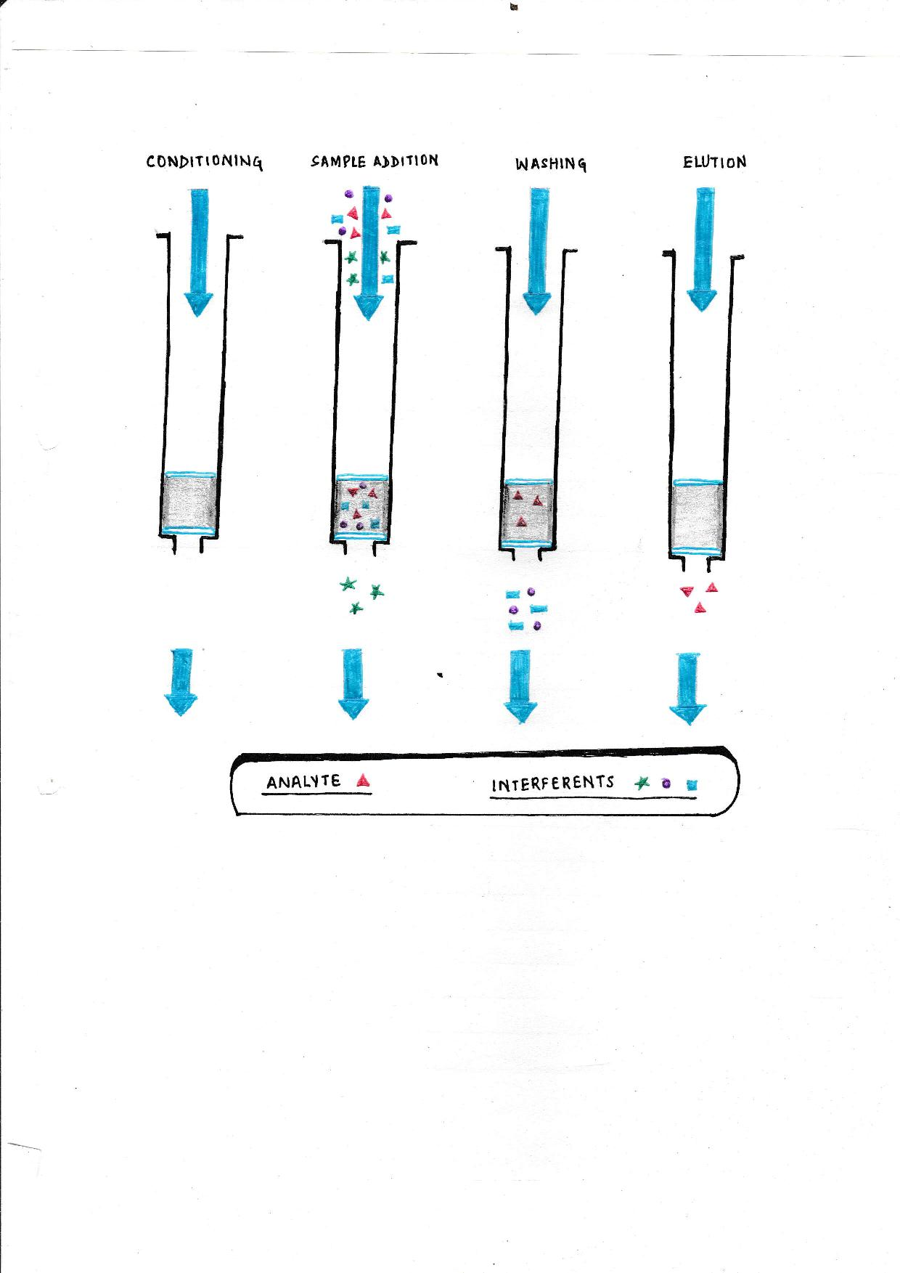

Figure 1.Separation of Antibiotic by Solid Phase Extraction Method (7)

Extraction by LLE
a). Liquid-Liquid Extraction for Cephalosporins and Carbapenems: A portion of
concentrated liquid was diluted with 10 ml of distilled water followed by addition of 40 ml of Chloroform-Ethanol (1:1) in a Separating funnel for 5 minutes[8]

Both the funnels were shaken to bring out substantial physical mixing. After shaking both the
phases were separated out and the phase containing analyte is then removed by freeze pour.

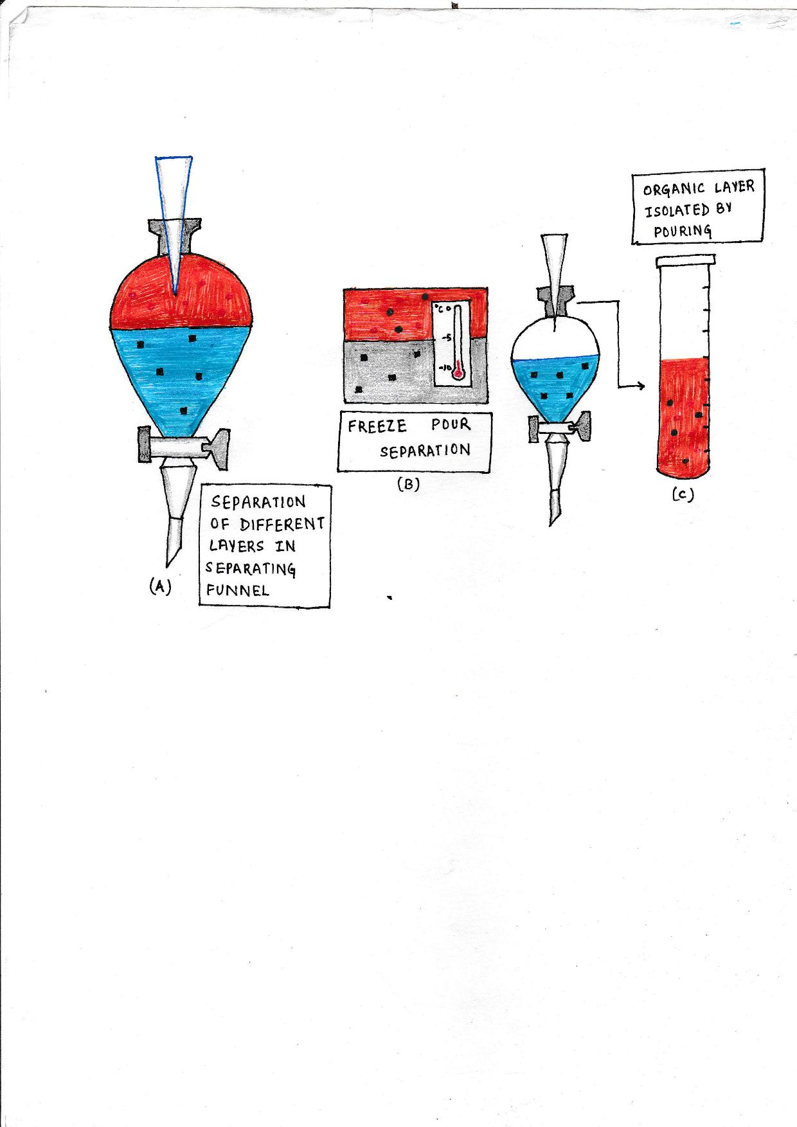

Figure 2.Separation of Cephalosporin and Carbapenem by Liquid-Liquid Extraction and freeze pour.

RESULTS AND DISCUSSION

The present study is based on isolation, cleanup and extraction of Cephalosporin and
Carbapenem Antibiotics from Forensic toxicological specimens using solid phase extraction and conventional Liquid-Liquid Extraction. The quantification of recovered Cephalosporin and
Carbapenem Antibiotics in different forensic matrices were done by using UV
Spectrophotometer. The recovery yield for Cephalosporin and Carbapenem Antibiotics by Solid Phase Extraction and Liquid-Liquid Extraction were compared. The mean analytical recovery of cephalosporin antibiotics were 3.55, 3.34 and 3.42 from Solid Phase Extraction. at spiking
concentration of 4 µg/ml respectively as compare to 2.44, 2.47 and 2.44 from Liquid-Liquid
Extraction. For Carbapenem Antibiotics it was 3.35, 3.5 and 3.27 from Solid Phase Extraction and 1.45, 2.52 and 1.45 from Liquid-Liquid Extraction.

The given Tables 1, 2, 3, 4, 5 and 6 shows comparison of percentage recovery of various
Cephalosporin and Carbapenem Antibiotics in Gastric Lavage, Viscera and Blood with known concentration of 4 µg/ml. The concentrations of extracted samples were compared after
processing with solid phase extraction and liquid-liquid extraction followed by quantitative analysis using UV Spectrophotometer.
Table-1: Comparison of percentage recovery of cephalosporin Antibiotics by S.P.E and L.L.E from Gastric Lavage

S. No. | Cephalosporin  Antibiotics Spiked  in Forensic  Specimen | Gastric Lavage
S. No. | Cephalosporin  Antibiotics Spiked  in Forensic  Specimen | Concentration  of Drug Spiked  (µg/ml) |  | Concentration of  Drug Extracted  (µg/ml)  Calculated by UV  spectrophotometer |  | Percentage of  Recovery of  Drug  Extracted
S. No. | Cephalosporin  Antibiotics Spiked  in Forensic  Specimen | S.P.E. | L.L.E. | S.P.E. | L.L.E. | S.P.E. | L.L.E
1. | Ceftriaxone | 4 | 4 | 3.7 | 2.4 | 92.5 | 60
2. | Cefixime | 4 | 4 | 3.2 | 2.2 | 80 | 55
3. | Cefepime | 4 | 4 | 3.6 | 1.8 | 90 | 45
4. | Cefpodoxime | 4 | 4 | 3.5 | 2.7 | 87.5 | 67
5. | Cefazolin | 4 | 4 | 3.7 | 1.7 | 92.5 | 42.5
6. | Cefpirome | 4 | 4 | 3.3 | 2.8 | 82.5 | 70
7. | Cephalexin | 4 | 4 | 3.3 | 2.9 | 82.5 | 72
8. | Cefotaxime | 4 | 4 | 3.8 | 2.5 | 95 | 62.5
9. | Cefuroxime | 4 | 4 | 3.7 | 2.9 | 92.5 | 72.5
10. | Cefadroxil | 4 | 4 | 3.7 | 2.5 | 92.5 | 62.5

Table-2: Comparison of percentage recovery of cephalosporin Antibiotics by S.P.E and L.L.E from Viscera

S. No. | Cephalosporin  Antibiotics Spiked  in Forensic  Specimen | Viscera
S. No. | Cephalosporin  Antibiotics Spiked  in Forensic  Specimen | Concentration  of Drug Spiked  (µg/ml) |  | Concentration of  Drug Extracted  (µg/ml)  Calculated by UV  Spectrophotometer |  | Percentage % of  Recovery of  Drug  Extracted
S. No. | Cephalosporin  Antibiotics Spiked  in Forensic  Specimen | S.P.E. | L.L.E | S.P.E. | L.L.E. | S.P.E. | L.L.E.
1. | Ceftriaxone | 4 | 4 | 3.3 | 2.5 | 82.5 | 62.5
2. | Cefixime | 4 | 4 | 3.1 | 2.6 | 77.5 | 65
3. | Cefepime | 4 | 4 | 3.0 | 2.7 | 75 | 67.5
4. | Cefpodoxime | 4 | 4 | 3.7 | 2.8 | 92.5 | 70
5. | Cefazolin | 4 | 4 | 3.5 | 2.9 | 87.5 | 72.5
6. | Cefpirome | 4 | 4 | 3.1 | 2.6 | 77.5 | 65
7. | Cephalexin | 4 | 4 | 3.1 | 2.0 | 77.5 | 50
8. | Cefotaxime | 4 | 4 | 3.3 | 1.9 | 82.5 | 47.5
9. | Cefuroxime | 4 | 4 | 3.4 | 2.2 | 85 | 55
10. | Cefadroxil | 4 | 4 | 3.9 | 2.5 | 97.5 | 62.5

Table-3: Comparison of percentage recovery of Cephalosporin Antibiotics by S.P.E and L.L.E from Blood

S. No. | Cephalosporin  Antibiotics Spiked  in Forensic  Specimen | Blood
S. No. | Cephalosporin  Antibiotics Spiked  in Forensic  Specimen | Concentration  of Drug Spiked  (µg/ml) |  | Concentration of  Drug Extracted  (µg/ml)  Calculated by  Spectrophotometer |  | Percentage % of  Recovery =  Concentration of  Drug  Extracted
S. No. | Cephalosporin  Antibiotics Spiked  in Forensic  Specimen | S.P.E. | L.L.E. | S.P.E. | L.L.E. | S.P.E. | L.L.E
1. | Ceftriaxone | 4 | 4 | 3.4 | 2.4 | 85 | 60
2. | Cefixime | 4 | 4 | 3.2 | 2.2 | 80 | 55
3. | Cefepime | 4 | 4 | 3.2 | 1.8 | 80 | 45
4. | Cefpodoxime | 4 | 4 | 3.5 | 2.7 | 87.5 | 67.5
5. | Cefazolin | 4 | 4 | 3.8 | 1.7 | 95 | 42.5
6. | Cefpirome | 4 | 4 | 2.9 | 2.5 | 72.5 | 62.5
7. | Cephalexin | 4 | 4 | 3.6 | 2.9 | 90 | 72.5
8. | Cefotaxime | 4 | 4 | 3.5 | 2.5 | 87.5 | 62.5
9. | Cefuroxime | 4 | 4 | 3.3 | 2.9 | 82.5 | 72.5
10. | Cefadroxil | 4 | 4 | 3.8 | 2.8 | 95 | 70

Table 4: Comparison of percentage recovery of Carbapenem Antibiotics by S.P.E and L.L.E from Gastric Lavage

S. No. | Carbapenem  Antibiotics  Spiked in  Forensic  Specimen | Gastric Lavage
S. No. | Carbapenem  Antibiotics  Spiked in  Forensic  Specimen | Concentration  of Drug Spiked  (µg/ml) |  | Concentration of  Drug Extracted  (µg/ml)  Calculated by UV  Spectrophotometer |  | Percentage % of  Recovery  Drug  Extracted
S. No. | Carbapenem  Antibiotics  Spiked in  Forensic  Specimen | S.P.E. | L.L.E. | S.P.E. | L.L.E | S.P.E. | L.L.E.
1. | Meropenem | 4 | 4 | 3.7 | 1.5 | 92.5 | 37
2. | Doripenem | 4 | 4 | 2.7 | 1.2 | 67.5 | 30
3. | Imipenem | 4 | 4 | 3.3 | 1.4 | 82.5 | 35
4. | Etrapenem | 4 | 4 | 3.7 | 1.7 | 92.5 | 42.5

Table-5: Comparison of percentage recovery of Carbapenem Antibiotics by S.P.E and L.L.E from Viscera

S. No. | Carbapenem  Antibiotics  Spiked in  Forensic  Specimen | Viscera
S. No. | Carbapenem  Antibiotics  Spiked in  Forensic  Specimen | Concentration of  Drug Spiked  (µg/ml) |  | Concentration of  Drug Extracted  (µg/ml)  Calculated by UV  Spectrophotometer |  | Percentage % of  Recovery  Drug  Extracted
S. No. | Carbapenem  Antibiotics  Spiked in  Forensic  Specimen | S.P.E. | L.L.E | S.P.E. | L.L.E. | S.P.E. | L.L.E.
1. | Meropenem | 4 | 4 | 3.5 | 2.8 | 87.5 | 70
2. | Doripenem | 4 | 4 | 3.1 | 2.4 | 77.5 | 60
3. | Imipenem | 4 | 4 | 3.6 | 2.3 | 90 | 57.5
4. | Etrapenem | 4 | 4 | 3.8 | 2.6 | 95 | 65

Table-6: Comparison of percentage recovery of Carbapenem Antibiotics by S.P.E and L.L.E from Blood

S. No. | Carbapenem  Antibiotics Spiked  in Forensic  Specimen | Blood
S. No. | Carbapenem  Antibiotics Spiked  in Forensic  Specimen | Concentration  of Drug  Spiked (µg/ml) |  | Concentration of  Drug Extracted  (µg/ml)  Calculated by UV  Spectrophotometer |  | Percentage % of  Recovery of  Drug  Extracted
S. No. | Carbapenem  Antibiotics Spiked  in Forensic  Specimen | S.P.E. | L.L.E. | S.P.E. | L.L.E. | S.P.E. | L.L.E.
1. | Meropenem | 4 | 4 | 3.6 | 1.7 | 90 | 42.5
2. | Doripenem | 4 | 4 | 2.8 | 1.4 | 70 | 35
3. | Imipenem | 4 | 4 | 3.1 | 1.2 | 77.5 | 30
4. | Etrapenem | 4 | 4 | 3.6 | 1.5 | 90 | 37.5

The Average (Mean) and Standard Deviation (S.D) are different measures of central tendency and dispersion respectively, which is an absolute nature of measurement. For comparative
decisions preference is given to relative measures to absolute measures. The computation tool used for such relative measures is Coefficient of Variation (C.V) which is defined as S.D/Mean × 100. We found that the C.V. value for Solid Phase Extraction is lower than conventional Liquid Liquid Extraction as given wide table 7 and 8.
Table-7: Values of Coefficient of Variation for Cephalosporin Antibiotics in different Biological Matrices

Cephalosporin Antibiotics
Technique | Gastric Lavage | Viscera | Blood
S.P.E. | 5.97 | 8.72 | 8.24
L.L.E. | 17.51 | 13.50 | 17.51

Table-8: Values of Coefficient of Variation for Carbapenem Antibiotics in different
Biological Matrices

Carbapenem Antibiotics
Technique | Gastric Lavage | Viscera | Blood
S.P.E. | 14.10 | 8.41 | 12.05
L.L.E. | 14.35 | 8.78 | 14.35

CONCLUSION

The research is focused on introducing new methodology for separation of Cephalosporin
Antibiotics from three Forensic specimens viz. Gastric Lavage, Viscera and Blood by Solid
Phase extraction and Liquid-Liquid Extraction. The results obtained reveal that percentage
recovery of Cephalosporin and Carbapenem Antibiotics was higher in solid phase extraction over conventional liquid-liquid extraction.

ACKNOWLEDGEMENT
The authors are thankful for providing INSPIRE Fellowship from Ministry of Science and Technology, DST, Government of India.

What is already known on this topic?
Solid Phase Extraction is hyphenated technique used worldwide. Its sensitivity is higher than conventional Liquid- Liquid Extraction.

What this study adds?
Our study reveals different methods for cleaning biological matrices like protein precipitation and dialysis. The worldwide used Solid Phase Extraction method found to be most suitable for extraction of drug analyte from forensic samples like blood, gastric lavage, and viscera. Since the analyte concentrations in forensic samples varies in limits .The SPE technique found to be more sensitized extraction procedure for recovery of Cephalosporin and Carbapenem antibiotics from forensic samples. Hence, Solid Phase Extraction found to be most suitable and reliable technique for separation of analyte molecule from different forensic matrices.

Suggestions for further development
Solid Phase Extraction method can also be used in isolation and identification of analyte molecules from unconventional biological fluids lie, vitreous humor, cerebro spinal fluid, amniotic fluid etc.

REFERENCES
1). Christelle Dufresne, Patrick Favetta1, Chantal Paradis and Roselyn Boulieu et.al
‘Comparative Study of Liquid-Liquid Extraction and Solid-Phase Extraction Methods for the Separation of Sufentanil from Plasma before Gas Chromatographic-Mass Spectrometric Analysis’ journal of Clinical Chemistry vol. 47 no. 3 600-602, March 2001
2). S. Bompadre, L. Ferrante and L. Leone ‘On-line solid phase extraction of cephalosporins’ Journal of Chrom. A, 812(1-2), 191-196, July 1998
3). Lebeau, Marc A et. al. ‘Analysis of biofluids for flunitrazepam and metabolites by electrospray liquid chromatography/mass spectrometry’ Journal of Forensic Sc.,45(5), 1133-1141, 2000
4). Sorensen L. K, Snor L. K. ‘Determination of cephalosporin’s in raw bovine milk by high performance liquid chromatography’ Journal of Chrom, 882(1-2), 145-151, 2000
5). Bruno, Federica, Curini, Roberta et.al ‘Solid phase extraction followed by liquid chromatography-mass spectrometry for trace determination of β-lactam antibiotics in bovine milk’ Journal of Agri. And Food Chem., 49(7), 3463-3470, 2001
6). Toxicology Manual, Directorate of Forensic Science of India.
7). Paolo Lucci, Deborah Pacetti, Oscar Núñez and Natale G. Fregaet. alp “Current Trends in Sample Treatment Techniques for Environmental and Food Analysis”. Chromatography - The Most Versatile Method of Chemical Analysis, Ch-5, 127-136, 2012
8). Sharma Shalvi, Agrawal Nitasha, Singh Jaskaran and Shukla S.K. ‘Qualitative analysis of 5th Generation of Carbapenem Antibiotics by UV Spectrophotometric Method’ Research Journal of Chemical Sciences, Vol. 5(7), 35-39, July (2015)
Web References:
9). http://www.chromacademy.com/lms/sco59/Sample_Preparation_Liquid-
Liquid_Extraction_Techniques.pdf

****

Ref - Singh J, Shukla SK, Sharma M, Kataria S, Kumar J. Comparative Study for Isolation and Clean-up Procedure by Solid Phase Extraction over Liquid-Liquid Extraction of Cephalosporin and Carbapenem antibiotics in forensic samples. Anil Aggrawal's Internet Journal of Forensic Medicine and Toxicology [serial online], 2018; Vol. 19, No. 2 (July - December 2018): [about 8 p]. Available from: http://anilaggrawal.com/ij/vol_019_no_002/papers/paper001.html. Published as Epub Ahead: Sep 26, 2016.

Access the journal at - http://anilaggrawal.com
************************************************************************

